# PHYSICS INVESTIGATION

IB PHYSICS SL

**What is the relation between the alacrity and different materials in the elastic and inelastic collisions?**

**Alexander Zhuk**

Candidate Number: 0060470168

EF Academy

# Word Count: 1457

**INTRODUCTION**

In this laboratory I’m going to measure different speeds after elastic and inelastic collisions. Moreover, this laboratory will also focus on the measurement of the different energies absorbed after elastic and inelastic collisions. Consequently, the aim of the experiment is to investigate the relation between the alacrity and different materials in the elastic and inelastic collision. This will be done by changing the mass of a cart, and then by using the different materials in the elastic and inelastic collision.

**VARIABLES**

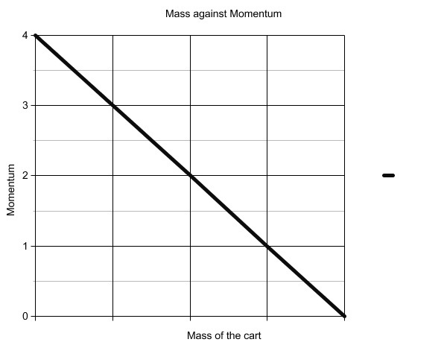

* The independent variable is the mass of the trolley
* The dependent variable is the momentum, which depends on the certain type of the collision as well as on the type of the materials used in the inelastic or elastic collision. It is measured in the kg m/s.
* The dependent variable is also the total kinetic energy after the elastic or inelastic collision occurs. It is measured in Joules.

**APPARATUS**

* 1-rail
* 2-trolleys
* 3-flat plates
* 4-plugs
* 5-launch pad
* 6-light barriers
* 7-instrument
* rubber and plastic plate - in order to see the **elastic collision**
* needle and plug - in order to see the **inelastic collision**

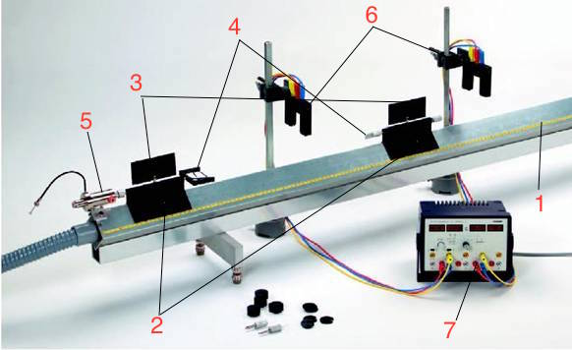

The experimental apparatus is a rail, on which two carts can move almost without friction. At the sides of the two carts there are inserted plates of a certain length 10 cm. Plugs of different types can be attached to the ends of the carts: rubber and plastic plate - in order to see the **elastic collision**;needle and plug - in order to see the **inelastic collision.** At the left side of the first cart you can see a starting system, which can be used to create speed for the first cart. This start system allows you to select three values ​​of speed. At the top of of the rail there are two devices called light barriers. They consist of a light source and a light receiver. When the cart goes through this light barrier, it covers a ray of light for a while, which gives light barrier an opportunity to measure the speed of the cart for specific time. This time can be measured and hence help to determine the speed of the cart.

Light barriers are connected to the timer. The instrument has 4 displays, on which I can see the time for the left and right cart and for the movement forward and backwards. Using this time, I can calculate the momentum, total energy before and after the elastic and inelastic collision.

**ELASTIC COLLISION**

Given numbers:

$\overset{→}{Vinitial1}$ and $\overset{→}{Vinitial2}$- are the speeds of the two carts before the elastic collision

$\overset{→}{v1}$ and $\overset{→}{v2}$- are the speeds after the carts had an elastic collision

Formulas used:

**Momentum conservation law and the law of conservation of energy**

$m_{1}\overset{→}{Vinitial1}+m_{2}\overset{→}{Vinitial2}=\left(m_{1}+m_{2}\right)\overset{→}{v_{final}}$

$$\frac{ { m_{1}\overset{→}{Vinitial1}}^{2}}{2}+\frac{ { m_{2}\overset{→}{Vinitial2}}^{2}}{2}=\frac{ { m_{1}\overset{→}{v_{1}}}^{2}}{2}+\frac{ { m_{2}\overset{→}{v_{2}}}^{2}}{2}$$

In order to get the speeds of v1 and v2 we can can use the momentum conservation law.

$$\overset{→}{v_{1}}=\frac{2m_{1}\overset{→}{Vinitial2}+(m_{1}-m_{2})\overset{→}{Vinitial1}}{m_{1}+m_{2}}$$

$$\overset{→}{v_{2}}=\frac{2m_{1}\overset{→}{Vinitial1}+(m_{2}-m_{1})\overset{→}{Vinitial2}}{m_{1}+m_{2}}$$

Using the experimental apparatus, I got these numbers and recorded them to these tables.

|  |  |  |  |  |  |
| --- | --- | --- | --- | --- | --- |
| t1initial s | t1 s | t2 s | $\overset{→}{{Vinitial}_{1}}$ m/s | $\overset{→}{v_{1}}$ m/s | $\overset{→}{v_{2}}$ m/s |
| 0,169 | 0,378 | 0,189 | 0,627 | 0,28 | 0,568 |
| 0,171 | 0,798 | 0,214 | 0,622 | 0,26 | 0,509 |
| 0,173 | 0,593 | 0,264 | 0,614 | 0,181 | 0,404 |
| 0,186 | 0,535 | 0,287 | 0,569 | 0,21 | 0,371 |
| 0,176 | 0,556 | 0,309 | 0,61 | 0,193 | 0,344 |
| 0,169 | 0,419 | 0,314 | 0,63 | 0,254 | 0,338 |

|  |  |  |  |  |  |  |  |  |  |
| --- | --- | --- | --- | --- | --- | --- | --- | --- | --- |
| m1 kg | m2 kg | P1initial kg m/s | P1 kg m/s | P2 kg m/s | P2-P1 kg m/s | W1initial J | W1 J | W2 J | W2+1 J |
| 0,39 | 0,63 | 0,245 | 0,109 | 0,358 | 0,249 | 0,076 | 0,015 | 0,102 | 0,117 |
| 0,39 | 0,69 | 0,242 | 0,101 | 0,351 | 0,25 | 0,075 | 0,0131 | 0,089 | 0,102 |
| 0,39 | 0,79 | 0,239 | 0,071 | 0,32 | 0,249 | 0,074 | 0,006 | 0,065 | 0,071 |
| 0,39 | 0,84 | 0,222 | 0,082 | 0,312 | 0,23 | 0,063 | 0,009 | 0,058 | 0,067 |
| 0,39 | 0,89 | 0,234 | 0,075 | 0,306 | 0,23 | 0,072 | 0,007 | 0,053 | 0,0537 |
| 0,39 | 0,94 | 0,245 | 0,099 | 0,295 | 0,196 | 0,077 | 0,013 | 0,054 | 0,067 |

1st graph- Mass of the second cart versus the momentum.

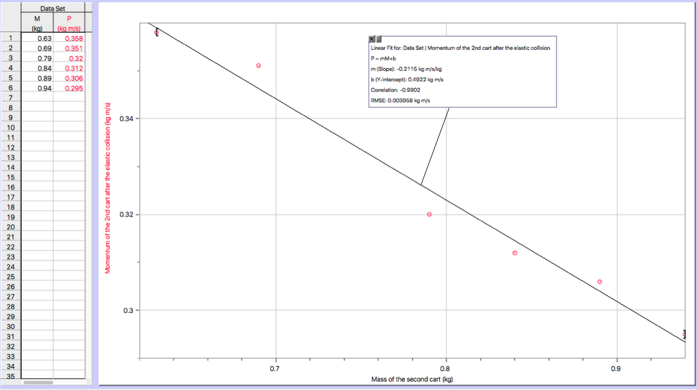

The following graph shows that mass is an independent variable, and momentum of the second cart is a dependent variable. Through this graph we can see that it’s decreasing as the slope is negative.

The variables for the mass increase, consequently we see a decrease in the momentum.

2nd graph. Mass of the second cart versus the total kinetic energy of the elastic collision.

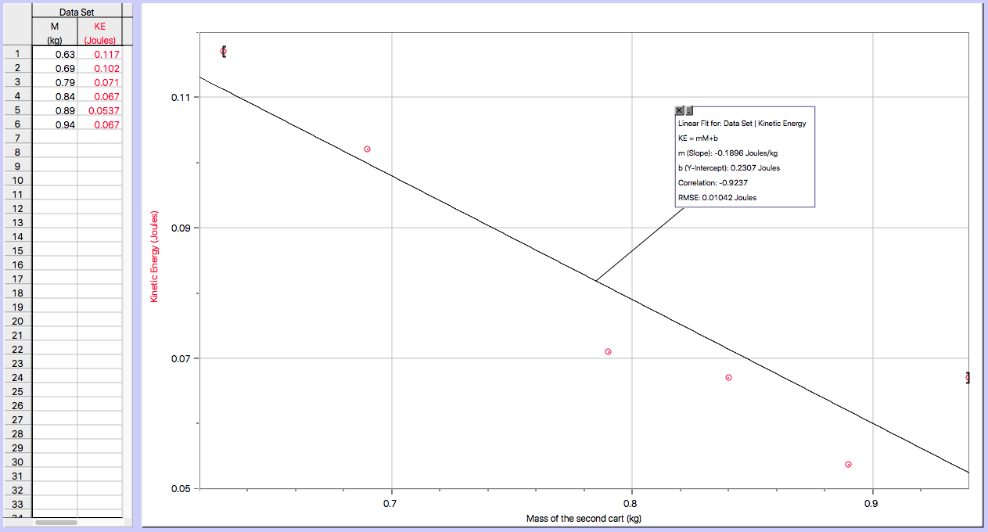

On that graph you can see a relationship between the mass of the second cart and the total kinetic energy involved in the whole lab. The bigger the mass gets the less kinetic energy we have in total. Through this graph we can also see that the slope is also negative. The variables for the mass increase, consequently there is a decrease in the kinetic energy, that directs us to the conclusion that the energy is being converted from the the potential energy of elastic deformation into kinetic energy.

**INELASTIC COLLISION**

Given numbers:

$m_{1}$, $m_{2}$– are the weights of the two carts.

$\overset{→}{Vinitial1} and \overset{→}{{Vinitial}_{2}} -$ are the speeds of the two carts before the inelastic collision.

$\overset{→}{v_{final}}$ is the speed after the carts had an inelastic collision.

Formulas used:

**Momentum conservation law**

$m_{1}\overset{→}{Vinitial1}+m_{2}\overset{→}{Vinitial2}=\left(m_{1}+m_{2}\right)\overset{→}{v_{final}}$

$$\overset{→}{v_{final}}=\frac{m_{1}\overset{→}{Vinitial1}+m_{2}\overset{→}{Vinitial2}}{m1+m2}$$

All of this might be calculated using the scalar expression, which can be used to show the path, way of the cart. Plus (+) sign can be used to show that the carts are going in one direction, while Minus (-) sign can be used to show that the carts are going in the direction from each other.

$$\overset{→}{v_{final}}=\frac{m_{1}\overset{→}{Vinitial1}∓m_{2}\overset{→}{Vinitial2}}{m1+m2}$$

It’s also interesting to know, that the amount of the mechanical energy, which transformed into the internal energy, equals in amount to the energy difference before and after inelastic collision: **«Mechanical energy** is the **sum** of the **potential** and **kinetic energies** in a system. »[1]

|  |  |  |  |  |  |  |
| --- | --- | --- | --- | --- | --- | --- |
| m1 kg | m2 kg | L(distance ) m | t1initial s | t s | $\overset{→}{{Vinitial}_{1}}$ m/s | $\overset{→}{vfinal}$ m/s |
| 0,39 | 0,44 | 0,1 | 0,164 | 0,318 | 0,625 | 0,292 |
| 0,39 | 0,49 | 0,1 | 0,17 | 0,334 | 0,614 | 0,243 |
| 0,39 | 0,54 | 0,1 | 0,161 | 0,321 | 0,622 | 0,26 |
| 0,39 | 0,59 | 0,1 | 0,169 | 0,325 | 0,634 | 0,252 |
| 0,39 | 0,64 | 0,1 | 0,168 | 0,325 | 0,611 | 0,23 |
| 0,39 | 0,69 | 0,1 | 0,169 | 0,326 | 0,603 | 0,225 |

|  |  |  |  |  |  |  |
| --- | --- | --- | --- | --- | --- | --- |
| m1 kg | m2 kg | m2/m1 | p1initial kg m/s | W1initial J | W J | Q J |
| 0,39 | 0,44 | 1,13 | 0,244 | 0,076 | 0,038 | 0,038 |
| 0,39 | 0,49 | 1.3 | 0,24 | 0,074 | 0,033 | 0,05 |
| 0,39 | 0,54 | 1.4 | 0,243 | 0,075 | 0,0365 | 0,047 |
| 0,39 | 0,59 | 1.51 | 0,247 | 0,078 | 0,03 | 0,04 |
| 0,39 | 0,64 | 1.64 | 0,238 | 0,073 | 0,027 | 0,032 |
| 0,39 | 0,69 | 1.77 | 0,235 | 0,071 | 0,025 | 0,037 |

3rd graph -Mass of the second cart versus the total kinetic energy of the inelastic collision.

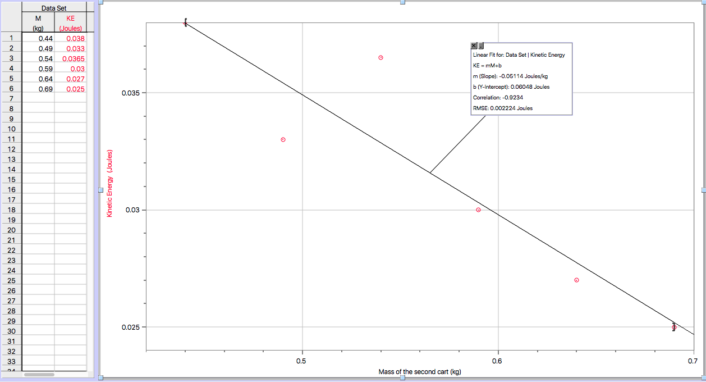

On that graph you can see a relationship between the mass of the second cart and the total kinetic energy involved in the inelastic collision. The bigger the mass gets the less kinetic energy we have in total. Through this graph we can also see that the slope is also negative. The variables for the mass increase, consequently there is a decrease in the kinetic energy.

**CONCLUSION**

When there is a complete **elastic collision**, kinetic energy of the colliding bodies transforms firstly into the potential energy of elastic deformation. Elastic deformation occurs with the help of rubber and plastic plate, which helps to create an elastic collision. Then, the body is back to its original shape, pushing each other. As a result, the potential energy of elastic deformation is again converted into kinetic energy, and body flies at speed. The magnitude and direction during the **elastic collision** are determined by two laws - the law of conservation of energy and momentum conservation law.

During **inelastic collision** kinetic energy is completely or partially converted into internal energy, leading to a rise in temperature of the bodies. In order to achieve inelastic collision, we use needle and plug. After impact, colliding bodies are moving together at the same speed or are at rest. In this case, after the impact bodies move together. When inelastic collision is performed only the law of conservation of momentum is working.

**EVALUATION**

Even though the relationships between the graphs presented in the following investigation are linear, it can be seen through the dots on the graph, that they occurred due to the errors in the investigation. The errors were created mostly due to the launch pad. An electromagnet would be a great thing for the launch pad. For example, when the launch pad releases its movement, electromagnet allows the cart to go freely. Consequently, the distance between the launch pad and the first car is really close without any uncertainties that allow the error to occur in the following investigation.

Other errors might be related to the fact that the first cart was not going straight sometimes on the rally. This could be improved by creating better and deeper area for the wheels of the carts. That it would be more stable in the whole process.

Finally, it would be even more interesting to conduct this whole lab with the third cart in the inelastic collision.

**BIBLIOGRAPHY:**

Conservation of energy. (n.d.). Retrieved February 10, 2016, from http://physics.bu.edu/~duffy/py105/EnergyConservation.html

1. Conservation of energy.